**18IT445,18IT446,18IT447**

**Aim:** Develop the system - optical mark recognition MCQ automated grading using python.

**Purpose of the system:**

The purpose of designing the system is to evaluate the human marked filling of multiple choice questions, questionnaires with true or false fields, and all types of document forms and show the grade according to their score.

**Scope of the system:**

The aim of this project is to design and developthe technology is used for collecting data from “fill-in-the-bubble” forms such as educational tests, surveys, assessments, evaluations, and many other multiple choice forms. Optical Mark Recognition enables the respondent to select an answer to a question by filling in a “bubble” or “mark” associated with an answer choice.

This technology will extract useful data from marked fields such as fill-in fields and checkboxes very quickly and with great accuracy. The most common use of OMR is in offices, academics and research departments where large numbers of hand-filled documents must be processed such as surveys, questionnaires, exams, reply cards and ballots. OMR can handle hundreds of thousands of physical documents per hour, and its accuracy is up to 99%. A common example is the use of standardized forms in schools where students have to fill in a predefined mark on the sheet, serving as a mark for the optical mark recognition algorithm.

The following tips will show its scope.

1. Friendly interfaces are also necessary in this project.
2. It must give users convenient and effective ways for grading the OMR sheet and other this type of the document.

**Architecture of the system:**

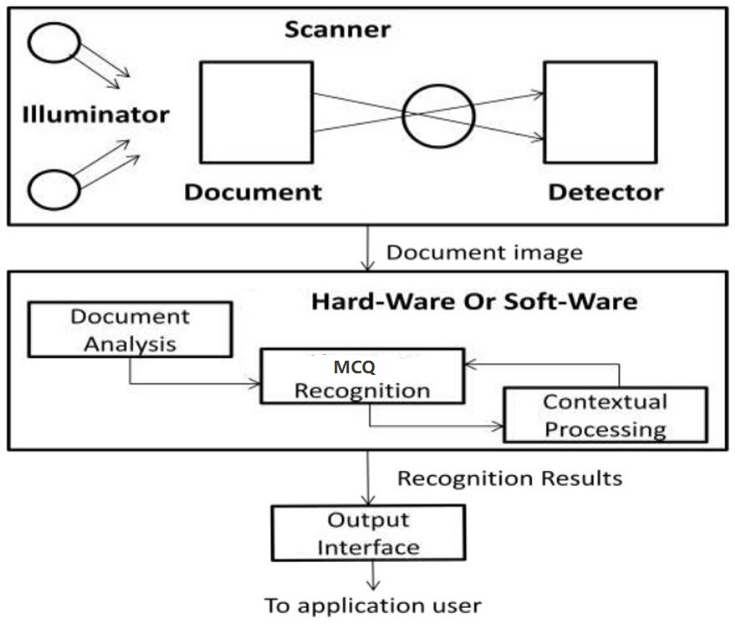

**Feasibility study:**

Preliminary investigation examines project feasibility, the likelihood the system will be useful to the organization. The main objective of the feasibility study is to test the Technical, Operational and Economical feasibility for adding new modules and debugging old running system. All systems are feasible if they are given unlimited resources and infinite time. There are aspects in the feasibility study portion of the preliminary investigation:

* Technical Feasibility
* Operational Feasibility
* Economic Feasibility

**1. Technical Feasibility:**

Technical feasibility deals with the hardware as well as software requirements. Technology is not a constraint to type system development. we have to find out whether the necessary technology, the proposed equipment has the capacity to hold the data, which is used in the project, should be checked to get technical feasibility.

The technical feasibility is used usually raised during the feasibility stage of investigation include below points:

* This software runs on any android and iOS device.
* The system can be expanded.

**2. Operational Feasibility:**

Proposed projects are beneficial only if they can be turned out into information systems, which will meet the organization’s operating requirements. Operational feasibility aspects of the project are to be taken as an important part of the project implementation.

This system is targeted to be in accordance with the above-mentioned issues. Beforehand, the management issues and user requirements have been taken into consideration. So there is no question of resistance from the users that can undermine the possible application benefits.

The well-planned design would ensure the optimal utilization of the computer resources and would help in the improvement of performance status.

**3. Economic Feasibility:**

This feasibility study present tangible and intangible benefits from the prefect by comparing the development cost. The technique of cost benefit analysis is often used as a basis for assessing economic feasibility.

This project is economic feasible. It does not require much more cost to be involved in the overall objective are in easing put the requirement processes.

**\* Modules and their functionalities:**

**1) Document Processing Model:**

This Module is accessed by administrator whose role in our application is a librarian. This module performs certain activities such as scanning documents, storing them as images, recognizing MCQs in images. During the recognition process, this module uses the OMR methodology in support of grid infrastructure datastructure. The module supports the following services:

1. Scanning printed Documents
2. Storing the document as snapshots or images.
3. Processing those image-based documents.
4. Converting these image-based documents into e-Documents (Also Called structured documents).
5. Recognizing the OMRs in documents.
6. Generating grid infrastructure datastructure.

**2) System training module:**

This module can be accessed by both the administrator and the end-user. Before Scanning the documents in to recognized and dimension establish, the first and the mandatory step is providing training to the system. Here training in the sense, the Area followed in the scanned document should be identified by the user. Then the user types all the MCQ Answer in Array Variable and also required for recognition from the scanned document as an image file. The user then clicks train(Run) button provide recognition module. Then the training gets completed. Thus System gets familiar with area of Document like rectangle circle and intensity. The module Support: -

* Training the System with pre-defined Area (Rectangle and circle and also image processing).
* Training the system with the new Area not present in the system and that cannot be identify by System

**3) Document recognition module:**

This module can be accessed by both administrator and the end-user. Once the printed documents are converted into structured documents, any user can recognize the MCQ present in the document. That means the user can recognize the MCQ of any language he chooses which make OMR more flexible. This flexibility is due to the adaption of grid infrastructure. This is the module where the main functionality of OMR is tested. Under this module, the scanned document recognition is there.

In scanned document recognition, the system is first trained with the bubble in the document in the training module itself. Now in the recognition module, the system takes the scanned documents image as an input file, first crops the image and then recognize the MCQ from the document and makes these documents editable and searchable. Thus the scanned document recognition recognizes the MCQ from the scanned document image and makes the document editable and searchable. Hence the document recognition module on a whole supports the following services:

* Convert the document into specific format
* Recognize the MCQ

**4) Document Editing Module:**

This module can be accessed by both the administrator and the end-user during document editing to implement the OMR reorganization process. Once the scanned documents are stored, they reside in computer memory. This data resides in the form of an image that is just viewable in an image viewer. Hence the document is first converted into a form such that it is editable. Objective of this module is to let the user perform: -

1. Addition of specific content to the documents
2. Deletion of certain content from Documents.
3. Any other modification of documents.

**5) Document searching module:**

This module can be accessed by both the administrator and end-user during the search of the user required document to implement the MCQ reorganization process on it. The user requests the system to search for a particular document. Then the system finds the documents based on OMR methodology and returns the result of the search to the user.

**Software Design:**

**Project Timeline Chart:**

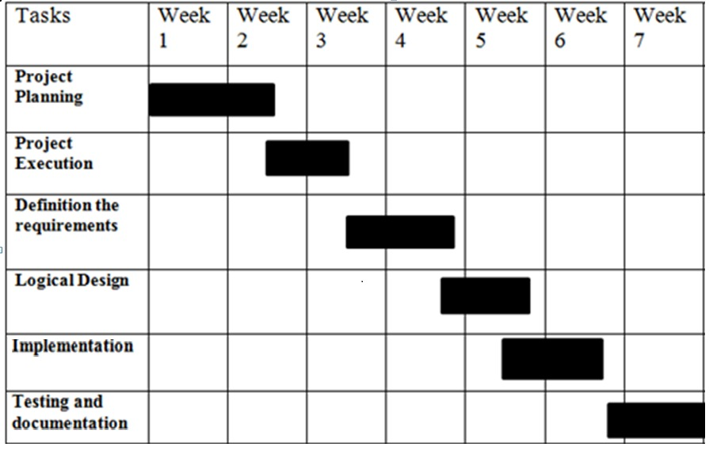

**Use-case Diagram**

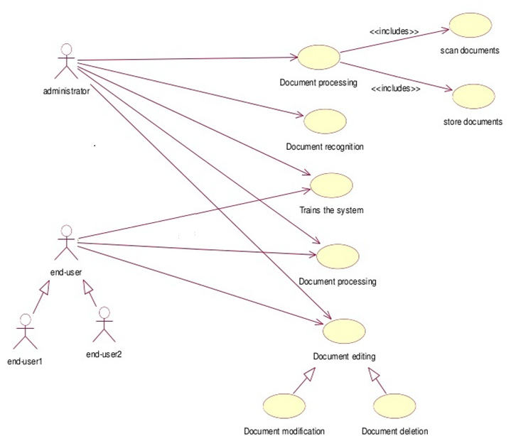

**Sequence Diagram**

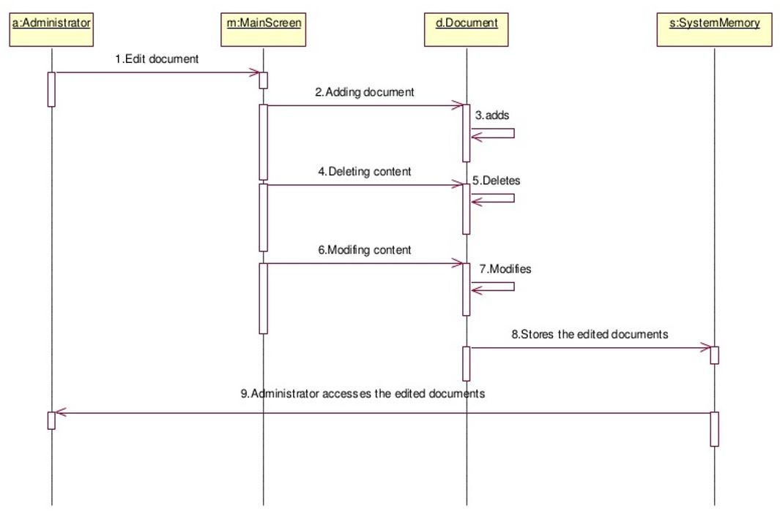

**Hardware Requirement:**

|  |  |  |
| --- | --- | --- |
| **Sr No.** | **Hardware Product:** | **Features** |
| **1** | Processor | Dual Core processor |
| **2** | RAM | Minimum 4GB RAM |
| **3** | Hardware Disk | 80 GB HDD |

**Software Requirement:**

|  |  |  |
| --- | --- | --- |
| **Sr no.** | **Software Product:** | **Source:** |
| 1 | Windows 10 | https://www.microsoft.com/en-in/software-download/windows10 |
| 2 | PyCharm(Editor) | https://www.jetbrains.com/pycharm/ |
| 3 | Python 3.9.1 | https://www.python.org/downloads/release/python-391/ |
| 4 | OpenCV | https://staging.opencv.org/ |
| 5 | NumPy | https://numpy.org/ |

**Work Distribution:**

* Mayur Jiyani: Project definition, architecture of system, system requirement, documentation and initial coding.
* Ashishkumar Dobariya: Feasibility studies and diagrams.
* Ritul Bathani: Project Modules.

**REFERENCES**

1. [**https://medium.com/@annywatson/**](https://medium.com/@annywatson/)
2. [**https://www.pyimagesearch.com**](https://www.pyimagesearch.com)
3. [**https://www.researchgate.net/publication/324924275**](https://www.researchgate.net/publication/324924275)
4. [**https://omrsoftware.com**](https://omrsoftware.com)